**PART 1:** Write the letter that corresponds to the correct answer in the space provided. You will ONLY be graded on the letter written and not on the circles made on the question. Each question is worth 1 point.

1. Which of the following statements is not true about computing systems?
2. An operating system is a special kind of software that enables other software to run
3. Software is typically written in a language that computers can understand
4. Recent computing advances are solely due to Moore’s law
5. The chip (i.e., central processing unit) is a part of computer responsible for executing operations
6. Which of the following statements is true about programming?
7. High level programming languages can only be understood by one operating system
8. Assembly language can be used on different computer architecture
9. It is difficult for humans to program in machine code
10. Snap is an example of an assembly language
11. Which of the following statements is true about classifiers?
12. The quality of a classifier is influenced by the training data
13. The quality of a classifier is influenced by the test data
14. The data must always be split 50 – 50 for training and test data to avoid bias.
15. It is easy to create unbiased classifiers for unambiguous tasks
16. When building a classifier, if the training data is biased in some way then
17. The test data is biased in the opposite way
18. The test data is biased in the same way
19. The test data is unbiased
20. The biasing of the test data and the training data is not related
21. Suppose you are sending an email, which is broken into packets for transmission over the internet. Which of the following statements is not true?
22. Each packet can take a different route
23. The packets may arrive out of order.
24. Some packets may not arrive at all.
25. None of the above
26. Which option best describes the color represented by the hexadecimal code: #A11F9F?
27. A shade of red
28. A shade of blue
29. A shade of green
30. A shade of purple
31. What is 4310 in binary?
32. 100101
33. 101101
34. 101101
35. 101011
36. None of the above
37. What is 2A16 in decimal?
38. 210
39. 42
40. 12
41. 34
42. None of the above
43. What is 101012 in decimal?
44. 11
45. 17
46. 13
47. 21
48. None of the above
49. The accuracy of a decision tree is determined by
50. the number of branches in the decision tree
51. the number of nodes in the decision tree
52. the correctness of the classification of new instances
53. the correctness of the classification of the training data
54. Which of the following regular expressions does not match the British postal code format i.e. A99 9AA where A represents an uppercase letter and 9 represents a number between 0 and 9
55. [A-Z]\d\d\s\d[A-Z][A-Z]
56. \u\d\d\s\d\u\u
57. \w\d\d\s\d\w\w
58. [A-Z]\d{2}\s\d[A-Z]{2}
59. None of the above
60. Which of the following does not match the regular expression \w+.\s\d{4}

1. Jan 1914
2. May 1914
3. October 1973
4. Apr. 1914
5. None of the above
6. What is the most likely explanation for the following graph?

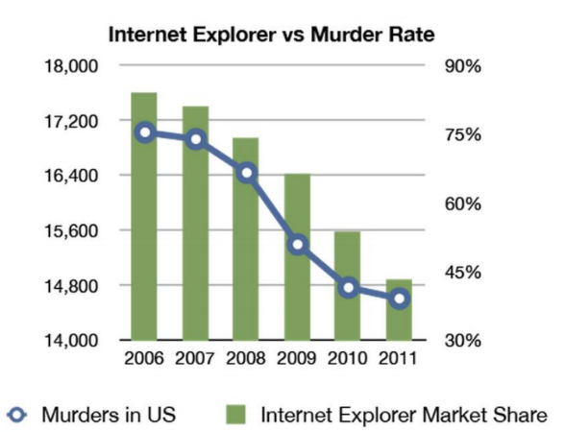

1. Internet Explorer users are very easily frustrated.
2. Americans are violent people.
3. The data is wrong.
4. Pure coincidence.
5. Which of the following visual representations is not based on position on an axis?
6. Bar chart
7. Parallel Coordinates
8. Network Graph
9. Radar Chart
10. Which of the following is not a Gestalt Principle?
11. Proximity
12. Similarity
13. Enclosure
14. Adjacency
15. Symmetry
16. Which of the following is not a strategy for designing infographics?
17. Refine Idea
18. Select Data
19. Analyze Data
20. Choose Graphics
21. In visual representations when comparing items, shading is more accurate than which of the following
22. Length
23. Angle
24. Area
25. Color saturation
26. How do neurons in ANN work?
27. They use neural electrons to solve translation problems
28. They solve one tiny function and pass the result on to another neuron
29. They duplicate the functionality of biological neurons exactly.
30. All of the above

|  |  |
| --- | --- |
| 1. What shape is formed when the following code is run? 2. Square 3. Circle 4. Pentagon 5. Hexagon 6. None of the above | Macintosh HD:Users:monaadib:Downloads:untitled script pic.png |

|  |  |
| --- | --- |
| 1. How many times will the sprite say “I’m rich”? 2. Never 3. Once 4. Twice 5. Six times 6. Forever | Macintosh HD:Users:monaadib:Downloads:untitled script pic (2).png |

**PART 2:** Write the answer in the space provided. Each question is worth 2 points.

1. _________________________________________ requires inferring parts of speech and sentence structure using a lexicon and grammar.
2. ____________________________________________ is used in defining patterns, generalizing from instances, and parameterization.  It is used to let one object stand for many.
3. ________ _______________________________________store information about your web browsing.
4. What is the name of this type of visual representation? ____________________________________

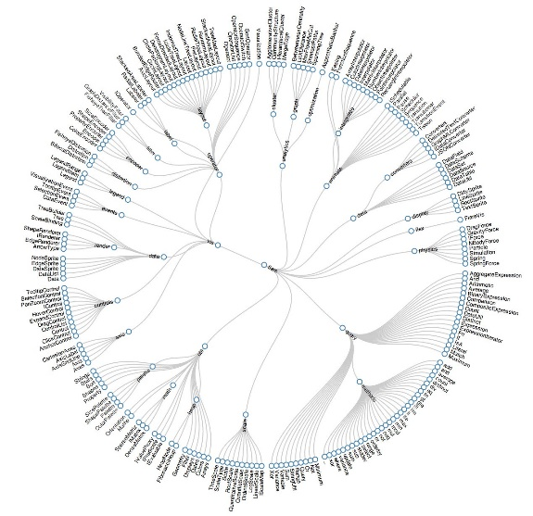

1. ________________________________________ requires inferring meaning using syntax and semantic rules.
2. What is the name of this type of visual representation? ______________________________________

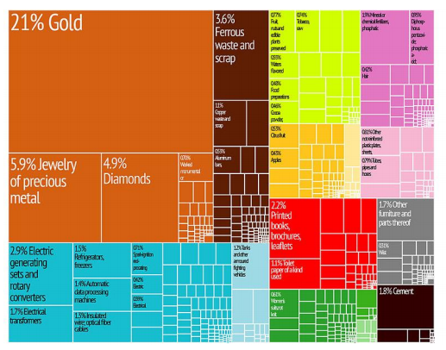

1. ______________________________________________________ is the thought processes involved in formulating problems and their solutions so that the solutions are in a form that can be effectively carried out by an information-processing agent.
2. In the context of image representation, _________________________ images are good at storing things with hard edges but can be computationally costly for blurring.
3. What is the name of this type of visual representation? ______________________________________

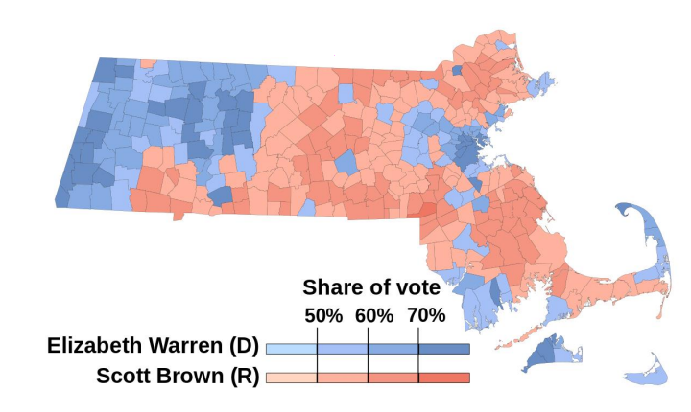

1. _____________________________________ requires inferring meaning from contextual information.

**PART 3: Short Answer Questions**

Write the answer in the space provided.

1. [6pts] List three ways that we evaluated algorithms over the course of the term.  
     
   ____________________________________________________________________________  
     
   ____________________________________________________________________________  
     
   ____________________________________________________________________________
2. [8pts] List four theories as to why there are few women in computer science.  
     
   ___________________________________________________________________________  
     
   ___________________________________________________________________________  
     
   ___________________________________________________________________________  
     
   ___________________________________________________________________________

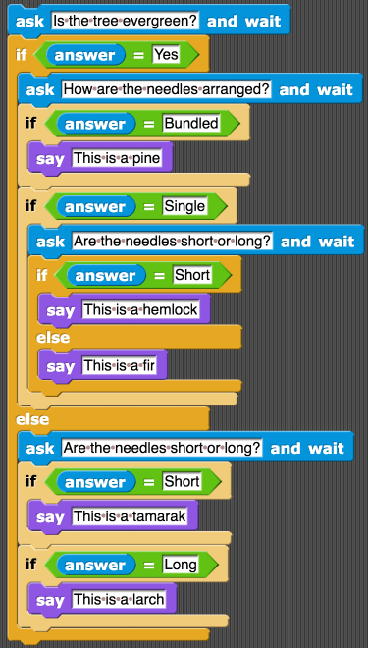

**Use the snap program shown above to answer questions 33 - 35**

[2pts each] Use the data shown in the table below for the input for each problem. In the fourth column (i.e., Output) write the output of the program for the specified input. Each row of the table represents a separate run of the program. **Note**: Not all the data provided may be necessary for each problem.

|  |  |  |  |  |
| --- | --- | --- | --- | --- |
| Q # | Evergreen? | Needle length? | Needle arrangement? | **Output** |
| 33 | No | Short | Tufted | 33___________________________________________ |
| 34 | Yes | Short | Bundled | 34___________________________________________ |
| 35 | Yes | Long | Single | 35___________________________________________ |

1. [3 pts] The following nine numbers are the blue RBG values for a picture. Based on the horizontal edge algorithm learned in the Image Representation lab, is there a blue horizontal edge? Why or why not?

|  |  |  |
| --- | --- | --- |
| 26 | 32 | 40 |
| 23 | 35 | 38 |
| 29 | 41 | 38 |

____________________________________________________________________________________

____________________________________________________________________________________

____________________________________________________________________________________

1. [2 pts] What does it mean to say that the k-means clustering algorithm *stabilizes*?  
     
   ___________________________________________________________________________________  
     
   ____________________________________________________________________________________

____________________________________________________________________________________

1. [2 pts] What is the *maximum* number of clusters that the k-means algorithm can produce, when the input is a dataset with 100 points and k = 5? Explain your answer briefly.   
     
   ___________________________________________________________________________________  
     
   ___________________________________________________________________________________  
     
   ____________________________________________________________________________________
2. [2 pts] What is the *minimum* number of clusters that the k-means algorithm can produce, when the input is a dataset with 1000 points and k = 4? Explain your answer briefly.

___________________________________________________________________________________  
  
__________________________________________________________________________________  
  
___________________________________________________________________________________

1. [2 pts] What is the Turing test?  
     
   ___________________________________________________________________________________  
     
   ___________________________________________________________________________________

___________________________________________________________________________________

1. [3 pts] Can computers pass the Turing test? Explain your answer.  
     
   ___________________________________________________________________________________  
     
   ___________________________________________________________________________________  
     
   ___________________________________________________________________________________
2. [6 pts] Write a regular expression that only matches mathematical expressions for adding, multiplying, dividing, or subtracting two numbers. The structure of the numbers is as follows. The first number can have up to three digits, while the second number is a single digit. Valid patterns that should be matched include the following. *Note - the list below just shows a sample, not every possible option.*

123*3

45-4

111/2

4+3

___________________________________________________________________________________  
  
___________________________________________________________________________________

1. [6 pts] This is a 3-part question (1) In the context of data representation and privacy, is the acronym/phrase WYSIWYG true? (2) Why or Why Not? (3) Give one real-world example.  
   WYSIWYG – What you see is what you get  
     
    ___________________________________________________________________________________

___________________________________________________________________________________  
  
___________________________________________________________________________________

___________________________________________________________________________________  
  
___________________________________________________________________________________  
  
___________________________________________________________________________________

1. [4 pts] In the context of Artificial Intelligence, what are two limitations of using structured rules/logic for real-world problems?  
   ___________________________________________________________________________________  
     
   ____________________________________________________________________________________  
     
   ____________________________________________________________________________________  
     
   ____________________________________________________________________________________
2. [4 pts] Describe a difference that you observed in the responses of Eliza and Cleverbot. Be as concrete as possible.

__________________________________________________________________________________

__________________________________________________________________________________

__________________________________________________________________________________  
  
__________________________________________________________________________________

1. [2 pts] Give an instance in which using a line chart is better than using an area chart.

____________________________________________________________________________________  
  
____________________________________________________________________________________

____________________________________________________________________________________

1. [4 pts] List four tips for creating infographics.

____________________________________________________________________________________

____________________________________________________________________________________

____________________________________________________________________________________

____________________________________________________________________________________

**This page has been intentionally left blank**

Note that any work that you do on this page will NOT be graded. If you want to do work here you MUST transfer it to the appropriate spot in the rest of the exam. The same holds for the page on the back of the cover sheet.

The binary conversion tables and regular expressions are on the next page

**Information you may find useful. This sheet will NOT be graded.**

|  |  |
| --- | --- |
| **Powers of two** | **Hexadecimal digits** |
| |  |  | | --- | --- | | 2 raised to the power of |  | | 0 | 1 | | 1 | 2 | | 2 | 4 | | 3 | 8 | | 4 | 16 | | 5 | 32 | | 6 | 64 | | 7 | 128 | | 8 | 256 | | 9 | 512 | | |  |  | | --- | --- | | Binary Representation | Hexadecimal representation | | 0000 | 0 | | 0001 | 1 | | 0010 | 2 | | 0011 | 3 | | 0100 | 4 | | 0101 | 5 | | 0110 | 6 | | 0111 | 7 | | 1000 | 8 | | 1001 | 9 | | 1010 | A | | 1011 | B | | 1100 | C | | 1101 | D | | 1110 | E | | 1111 | F | |

**REGULAR EXPRESSIONS**

Non-specific characters.

\d for any digit from 0 – 9

\D for any non-digit character

\w for any word character (alphanumeric)

\W for any non-word character (non alphanumeric)

\l for any lower case letter

\u for any upper case letter

\s for any space

. used to match any single character

[ ] match one of the characters in the [ ]

[^xyz] exclude x, y and z (any character except the listed characters)

[# - #]: where # represents any alphanumeric character.

#{max} exact number of repetitions

#{min, max}

Matching an arbitrary number of characters

* 0 or more repetitions

+ 1 or more repetitions

? used when a character is optional

(…) a part of the regular expression

(str|str) alternative choices.

**This page has been intentionally left blank**

Note that any work that you do on this page will NOT be graded. If you want to do work here you MUST transfer it to the appropriate spot in the rest of the exam. The same holds for the page on the back of the cover sheet.